

**Infocomm Sales and Marketing**

Year 2/3 (2024), Semester 3/5

**SCHOOL OF INFOCOMM TECHNOLOGY**

Diploma in Data Science

Diploma in Information Technology

**ASSIGNMENT I  
Individual**

|  |  |  |
| --- | --- | --- |
| **Deadline:** | **Softcopy** | **9 June 2024 @ 2359 hrs** |

|  |  |
| --- | --- |
| **Tutor :** | Mr. Leonard Lee |
| **Tutorial Group:** | T-02 |
| **Student Name:** | Tan Jun Yu Zavier |
| **Student Number:** | S10255651D |

**Penalty for late submission:**

* 10% of the marks will be deducted for everyday (inclusive of Saturdays, Sundays, and Public Holidays) after the deadline.
* **NO** submission will be accepted after 19 June 2024, @ 2359hrs

**Contents**

1. Background of Philips Healthcare 4

2. PEST Analysis 5

2.1 Political 5

2.2 Economic 6

2.3 Sociocultural 7

2.4 Technological 7

3. Michael Porter’s 5 Force Analysis 9

3.1 Threat of New Entrants (Low – Moderate Risk) 9

3.2 Suppliers Power (Low – Moderate Risk) 10

3.3 Buyers Power (Moderate – High Risk) 10

3.4 Threat of Substitution (High Risk) 11

3.5 Competitive Rivalry (High Risk) 11

4. Industry Life Cycle 12

4.1 Rapid Market Expansion 12

4.2 Technological Advancements and Innovation 12

4.3 Increased Investment & Funding 13

4.4 Growing Market Acceptance 13

4.5 Competitive Landscape 15

5. Philips Healthcare Value Chain Analysis 16

5.1 Inbound Logistics 16

5.2 Operations 16

5.3 Outbound Logistics 16

5.4 Marketing and Sales 17

5.5 Services 17

6. Philips Healthcare SWOT Analysis 18

6.1 Strengths 18

6.2 Weaknesses 19

6.3 Opportunities 19

6.4 Threats 20

7. Philips Healthcare BCG Model 22

7.1 High Market Growth 22

7.2 High Market Share 22

8. Philips Healthcare Product Life Cycle 23

8.1 Rapid Adoption & Integration 23

8.2 Expansion & Scaling 23

8.3 Market Penetration & Revenue Growth 24

9. Recommendations 25

9.1 Enhance Research & Development (R&D) 25

9.2 Enhance Cybersecurity & Data Privacy 25

9.3 Focus on Sustainability 26

10. Conclusion 28

10.1 Problem Identification 28

10.2 AI Tools Chosen 28

10.3 Interaction with AI Tools 28

10.4 Reflection 29

11. Citations & References 30

# Background of Philips Healthcare

Philips Healthcare, a division of the Dutch multinational conglomerate, has a rich history spanning over 130 years. The company’s journey marked by their continuous innovation and entrepreneurship, contributing significantly to the advancements in healthcare technology.

**1890s**

Founded in 1891 by Frederik Philips and his son Gerard, the company initially focused on cost-effective electric incandescent light bulbs, capitalizing on the mass-market introduction of electricity.

**1910s**

The establishment of the Philips research laboratory in 1914 fostered scientific research and led to groundbreaking advancements in lighting technologies, X-ray tubes, and healthcare technology.

**1990s**

As technologies became more complex, there was a rise of products designed to be easier to use. Philips adopted a human-centered approach to product design entitled ‘Design for Life’, which harmonized and integrated all aspects, improving patient experience and throughput.

**2010s**

Inspired by its purpose to improve people’s health and well-being through meaningful innovation, Philips aims to improve the lives of 2.5 billion people per year by 2030. Today its growing portfolio of innovative health technology solutions supports value-based care across the health continuum.

[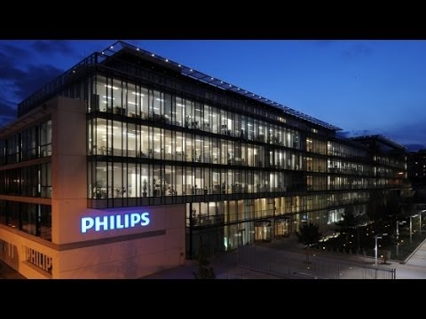](https://www.youtube.com/embed/XDwppV4nl_c?feature=oembed)

# PEST Analysis

PEST Analysis (political, economic, social and technological) is a management method whereby an organization can assess major external factors that influence its operation to become more competitive in the market. As described by the acronym, those four areas are central to this model.

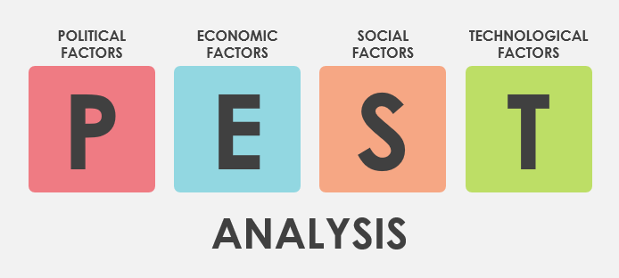

# Political

* **Regulatory Environment:** Philips Healthcare operates in an industry with stringent regulations. Compliance with health regulations, safety standards, and data privacy laws, such as the General Data Protection Regulation (GDPR) in Europe, is essential. For example, GDPR requires Philips to apply very strict data protection measures for its AI-driven healthcare solutions, which process large amounts of sensitive patient data. Non-compliance can result in high penalties and interruptions in operations, leading to increased costs and affecting the business processes. Therefore, adhering to these regulations is crucial for Philips to avoid any legal and financial repercussions and ensure the ethical use of AI in healthcare.
* **Trade Policies and Tariffs:** Philips, being an international company, is significantly impacted by international trade policies and tariffs. Political tensions and trade disputes can disrupt the supply chain. For instance, the U.S.-China trade war led to tariffs that increased operational costs for AI components. Philips will need to make strategic adjustments to minimize financial impacts from such disruptions, ensuring a stable supply for its AI technologies. Hence, understanding and navigating trade policies and tariffs is essential for Philips to maintain operational efficiency and cost-effectiveness.

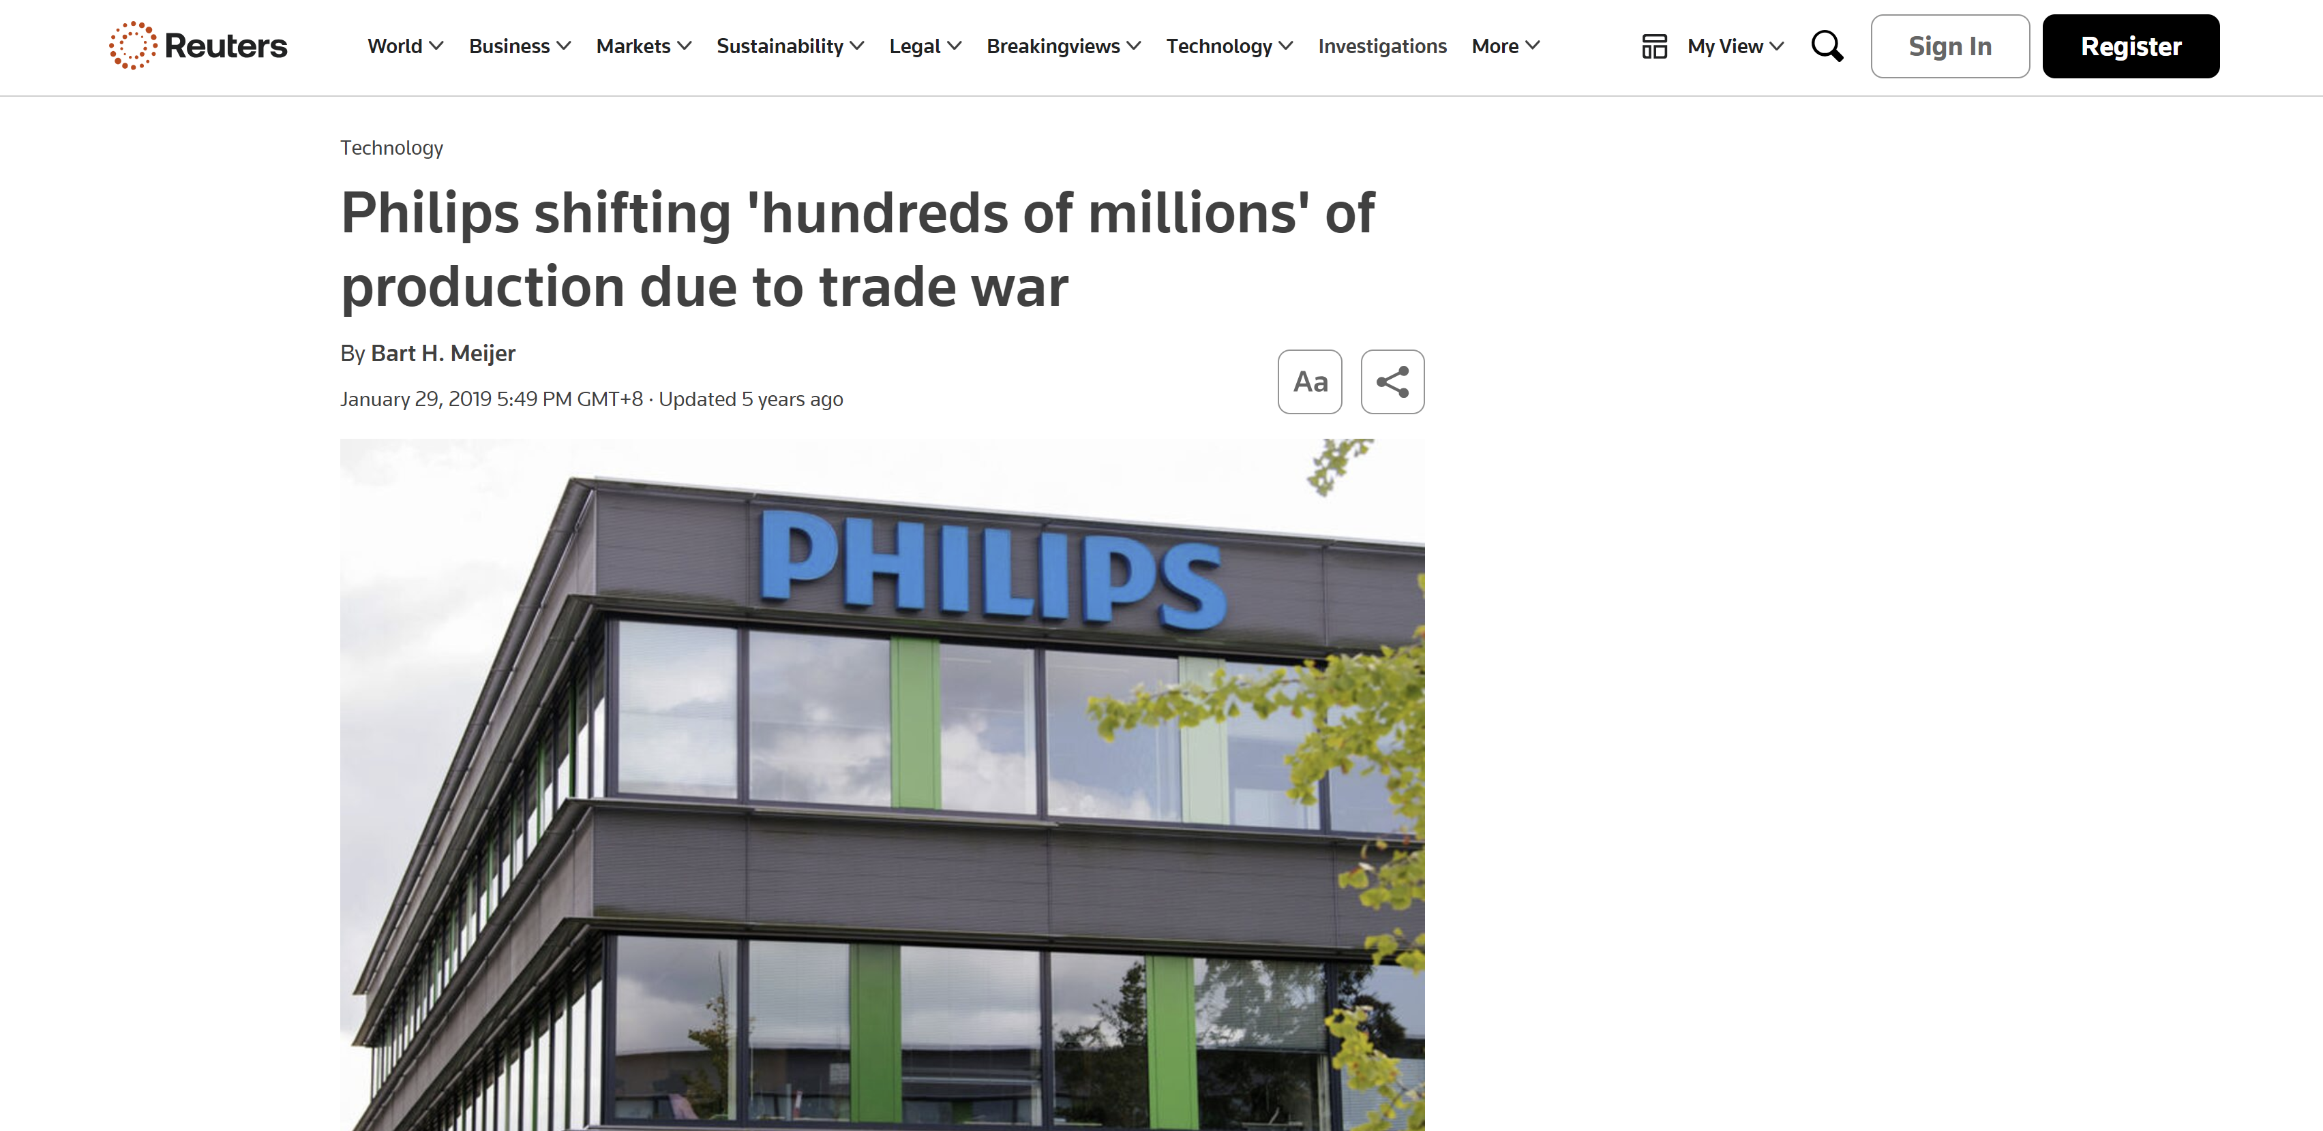

# Economic

* **World Economic Conditions:** Economic stability and growth rates are critical in determining healthcare spending. Economic downturns can reduce budgets allocated to healthcare, leading to decreased sales for Philips. For example, during recessions, budget cuts in healthcare spending can significantly impact investment in AI-driven healthcare solutions. Economic stability is vital for ensuring consistent demand for AI healthcare products. Therefore, monitoring global economic conditions helps Philips plan and strategize to mitigate potential adverse effects on its business.
* **Healthcare Spending:** The overall expenditure on healthcare directly influences the demand for medical appliances. Rising healthcare costs drive the need for cost-effective solutions. Increased healthcare spending can lead to higher demand for Philips' innovative AI solutions, such as AI-powered diagnostic tools and predictive analytics. Therefore, aligning AI products with healthcare spending trends is essential for growth.

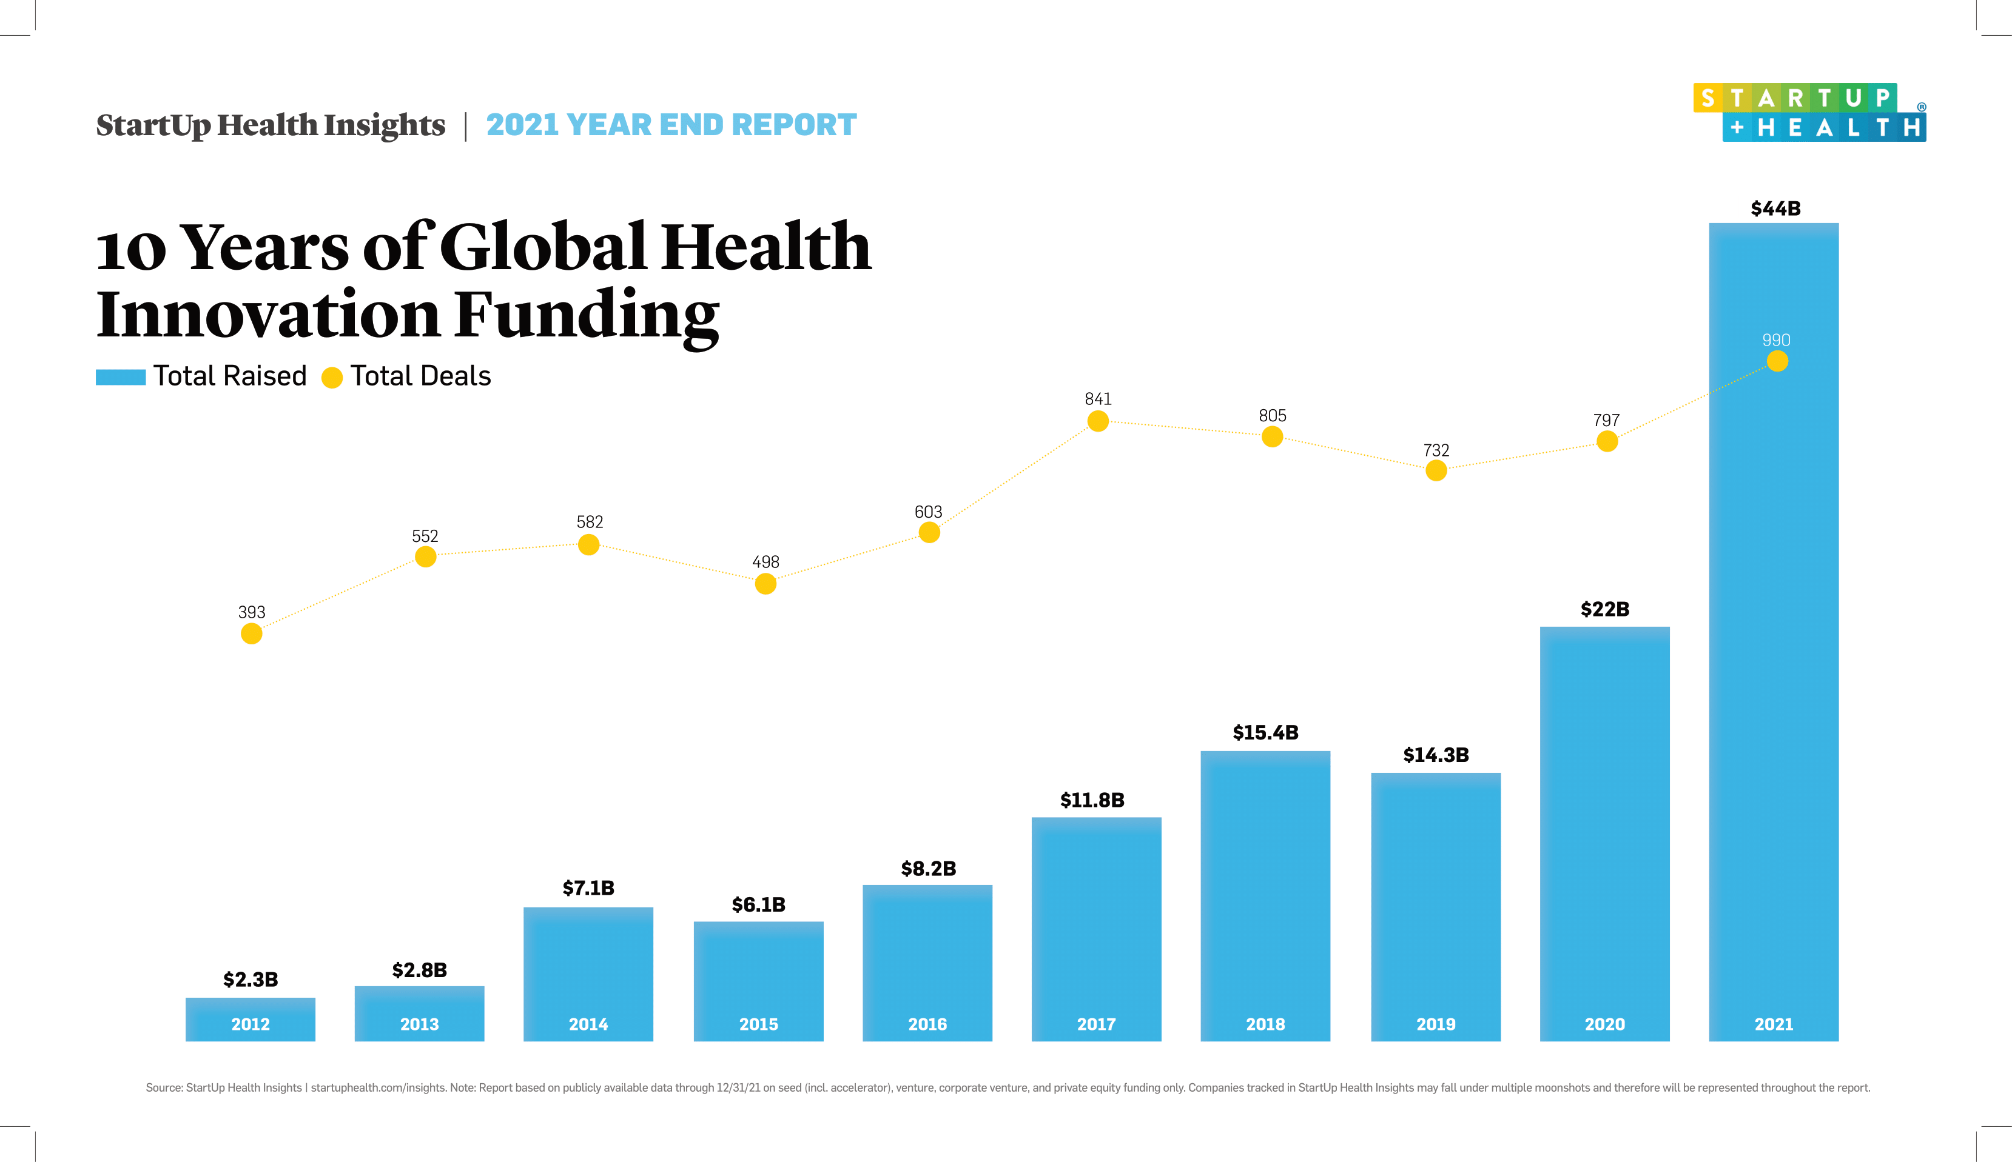

# Sociocultural

* **Aging Population:** The aging population accelerates the demand for healthcare services and products. Elderly individuals require more medical care and monitoring, leading to increased demand for Philips' diagnostic imaging and patient monitoring systems. For example, demographic trends showing a rise in the elderly population directly impact product demand for AI technologies. Therefore, demographic analysis is crucial for Philips to anticipate and cater to market demands effectively.
* **Patient-Centric Care:** There is a significant shift towards personalized medicine and patient-centric care. Patients now demand better healthcare experiences and outcomes. Philips' patient engagement technologies, powered by AI, are increasingly in demand. Improved patient experience drives the adoption of Philips’ AI solutions. Therefore, focusing on enhancing patient care through innovative AI technologies is the key to meeting market expectations and maintaining a competitive edge.

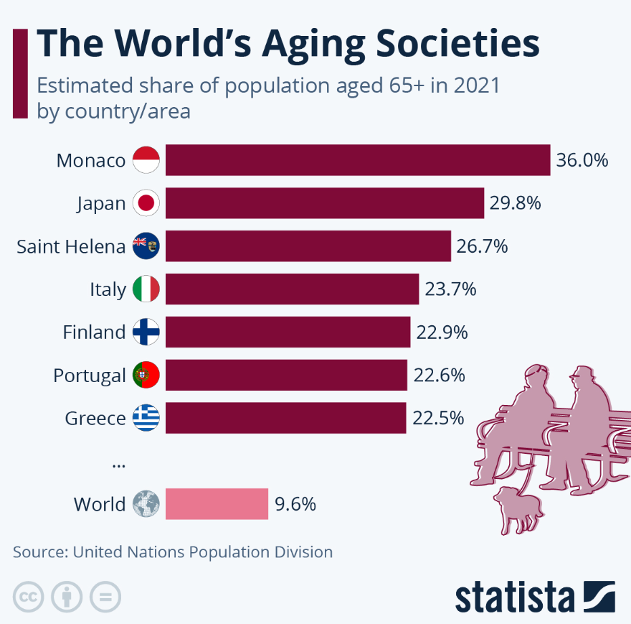

# Technological

* **Innovation in Medical Technology:** Rapid advancements in medical technology create numerous opportunities for Philips Healthcare. Innovation is critical to maintaining a competitive edge. For example, Philips' development of advanced imaging systems and AI-driven technologies positions it as a market leader. Hence, continuous innovation is essential for sustaining growth and market share. Therefore, investing in cutting-edge technologies is crucial for Philips to stay ahead in the healthcare industry.
* **Research & Development Investment (R&D):** A strong commitment to R&D is vital for Philips Healthcare. Continuous product development drives growth and market presence. For instance, Philips' significant R&D investments lead to the creation of innovative AI healthcare solutions, such as advanced algorithms for diagnostics and personalized medicine. Hence, ongoing investment in R&D ensures that Philips remains at the forefront of medical technology advancements. Prioritizing R&D is fundamental to Philips' long-term success.

# Michael Porter’s 5 Force Analysis

Porter's Five Forces is a model that identifies and analyzes five competitive forces that shape every industry and helps determine an industry's weaknesses and strengths. Five Forces analysis is frequently used to identify an industry's structure to determine corporate strategy. Porter's model can be applied to any segment of the economy to understand the level of competition within the industry and enhance a company's long-term profitability.

Using Philips Healthcare to determine which industry it is in; it falls under between 2 markets. This market integrates aspects of both the MedTech sector and AI market, but we will be primarily focusing on the intersection of these two areas.

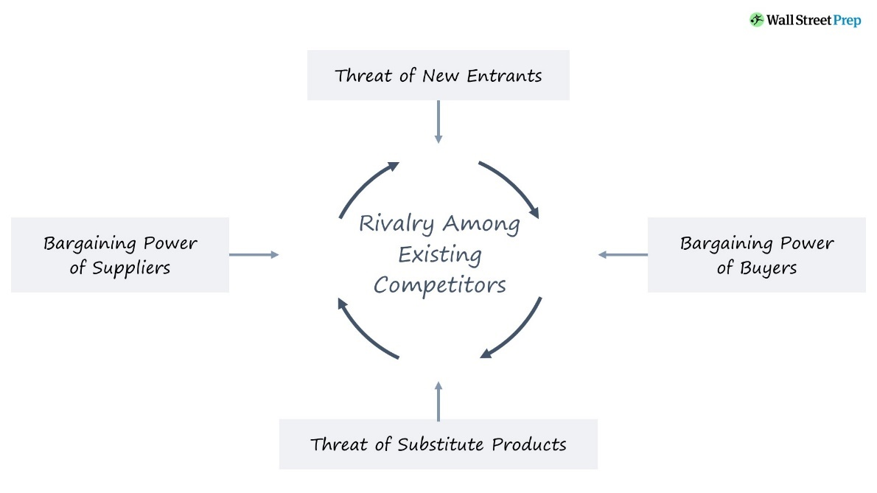

# Threat of New Entrants (Low – Moderate Risk)

* **Significant R&D Investment:** To develop and commercialize competitive AI-powered healthcare solutions, it would require a substantial amount of money invested in research and development (R&D). New entrants will need to have the resources to keep up with the rapid advancements in AI technology, invest in building expertise in both healthcare and AI, and develop and robust algorithms for their solutions.
* **Established Brand Reputation & Market Share:** Philips Healthcare, along with other well-established players within the MedTech Industry, holds a strong brand reputation and have significant market share. Philips existing reputation can make it difficult for new entrants to gain traction and trust from healthcare provider who are already familiar with and comfortable sticking to established brands like Philips. Moreover, Philips’s vast network and established customer base can create a huge hurdle for new entrants to penetrate the market effectively.
* **Strict Regulatory Requirements:** Medical devices with AI capabilities will require extensive clinical trials and approval processes from regulatory bodies like the Food and Drug Administration (FDA) to ensure safety and efficacy. This creates a significant barrier to entry for new players in the market. New entrants will need to navigate complex regulations and invest heavily in clinical trials before launching their products, which can be a lengthy and expensive process.

# Suppliers Power (Low – Moderate Risk)

* **Diversified Supplier Base:** Companies sources components from a wide range of suppliers, which reduces dependence on any single supplier. For example, Philips sources AI chips, cloud computing services, and other critical components from multiple suppliers, ensuring flexibility and reducing the risk of supply chain disruptions. Therefore, this diversification reduces the supplier power.
* **Supplier Switching Costs:** While switching suppliers can be costly, the effect is most of the time mitigated by long-term contracts and strategic partnerships. For instance, Philips and AWS collaborate to scale digital pathology in the cloud, enhancing diagnostic capabilities and improving productivity. Philips can consider partnering with other cloud services like google cloud, which helps ensure stable relationship and conditions of supply. Hence, reducing the need to keep switching to different suppliers.

# Buyers Power (Moderate – High Risk)

* **Product Differentiation:** AI-driven healthcare solutions are highly differentiated, reducing buyer power by offering unique value proposition. For example, Philips’ IntelliSpace AI Workflow Suite integrates seamlessly with hospitals systems, offering advanced features like predictive analytics and workflow optimization that will be tough for competitors to match the level of efficiency without any heavy investment. Therefore, this reduces buyer power.
* **High Switching Costs:** High switching costs that are associated with training, integration, and interoperability of the new AI systems will limit buyer power. For instance, once a hospital has integrated Philips’ AI diagnostic tools into its workflow and trained its staff like how to use, switching to a new entire system would involve significant time and expense to switch and retrain staff which will be time being wasted, reducing the likelihood of switching. Therefore, once these systems are integrated, buyers may be less inclined to switch to competitors.

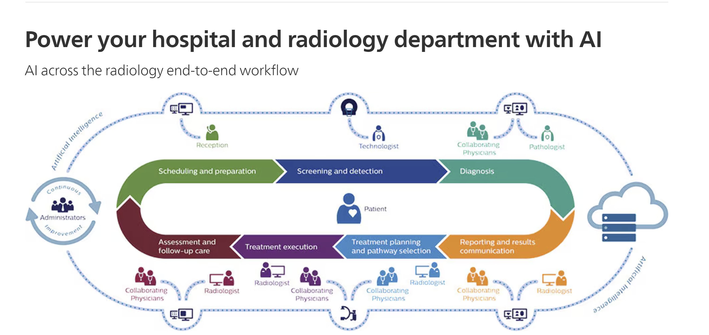

# Threat of Substitution (High Risk)

* **Rapid Technological Advancements:** The AI healthcare market is characterized by the continuous innovation. Rapid advancements can lead to development of even better and superior alternatives. For example, new AI algorithms and diagnostic tools made from emerging startups that can prove it offers higher accuracy and faster processing by miles, will indefinitely pose a threat to Philips’ existing solutions. Ultimately these new AI algorithms and diagnostic tools can outperform existing solutions and lead to a switch if the results are a huge leap.
* **Environmental & Government Incentives:** Government incentives for more environmentally friendly products enhance the threat of substitution. Initiatives such as tax breaks and credits can highly encourage more development of greener products. For example, The Dutch Green Funds Scheme (GFS) is a tax incentive used by the Dutch government to promote environmentally friendly initiative. Consequently, such incentives support the creation of superior alternatives that are more environmentally friendly, increasing the threat of substitutes.

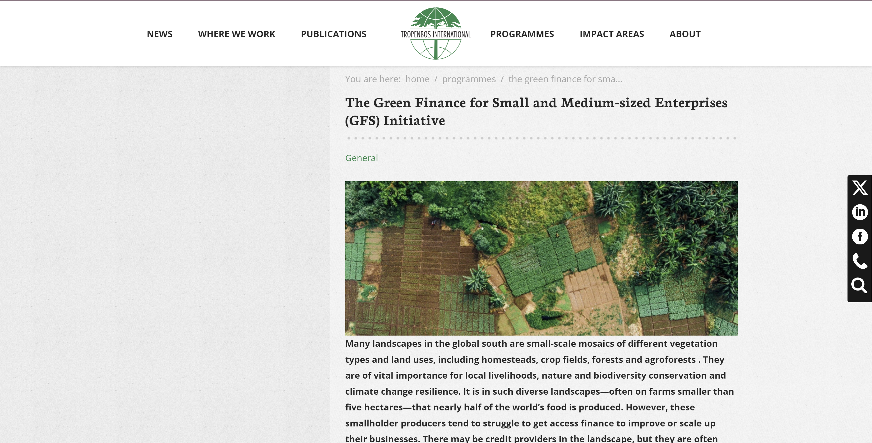

# Competitive Rivalry (High Risk)

* **Competitive Landscape:** The AI healthcare market includes strong competitors like GE Healthcare, Siemens Healthineers, and emerging startups can lead to intense competition. For example, GE Healthcare and Siemens Healthineers does continuously introduce new AI-driven products, which directly competes with Philips for markets share in diagnostic tools and patient monitoring systems. Hence, creating a very tight competitive landscape among these big players.
* **Price Wars & Cost Competition:** Among the big players, intense competition can also lead to price wars, impacting profitability. For example, competitors might choose to reduce their price slightly to capture more market share as more will opt for their products instead, forcing Philips to adopt similar pricing strategies to contest and maintain its position. Hence, effective pricing strategies are essential to remain competitive in the market.

# Industry Life Cycle

The Industry Life Cycle tool is a useful tool for analyzing the effects of industry evolution on competitive forces is the industry life cycle model, which involves five stages, including embryonic, growth, shakeout, mature, and decline stages.

As mentioned earlier, the MedTech industry sits at the intersection of the MedTech and AI in Healthcare markets, combining advanced medical technologies with AI to improve healthcare delivery and outcomes. Based on recent industry analyses, this sector is currently in the “Growth” Stage of the industry life cycle and here are a few factors.

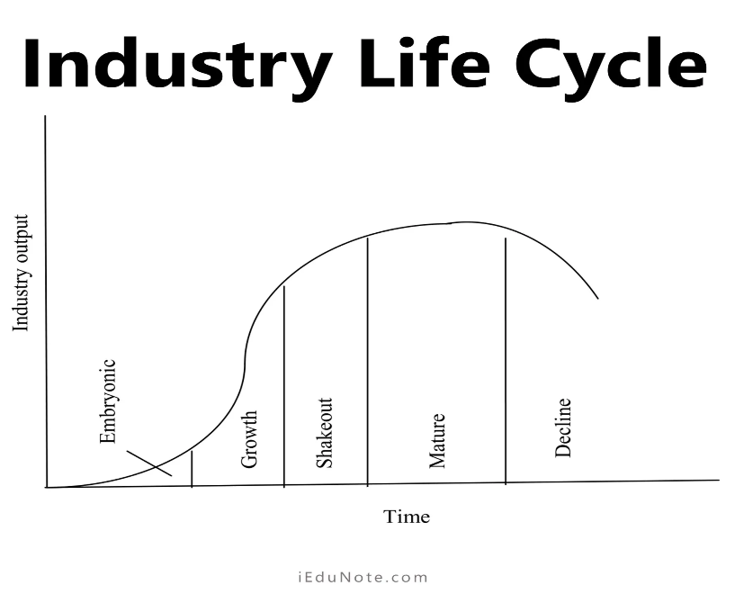

# Rapid Market Expansion

* The AI in healthcare market is expected to grow significantly, with a compound annual growth rate (CAGR) of 38.5% from 2024 to 2030. This growth is driven by increasing demand for efficient, accurate, and personalized healthcare solutions.
* Key application such as AI-driven diagnostic tools, predictive analytics, and robotic surgeries are seeing widespread adoption and investment.

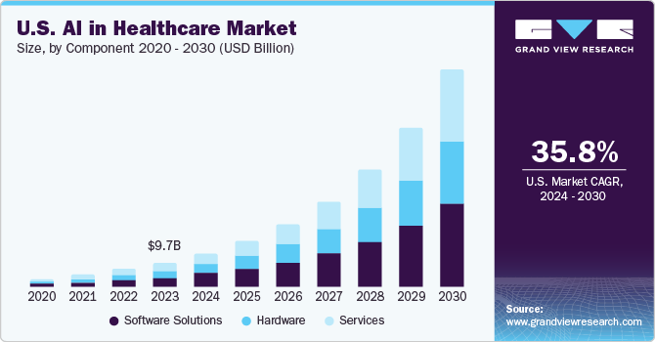

# Technological Advancements and Innovation

* Continuous advancements in AI technologies, including machine learning, natural language processing (NLP), and robotics, are propelling the market forward. Innovations are enhancing clinical documentation, drug discovery, and patient care.
* Companies are investing heavily in R&D to develop new AI applications that improve diagnostic accuracy, streamline clinical workflow, and personalize patient treatments.

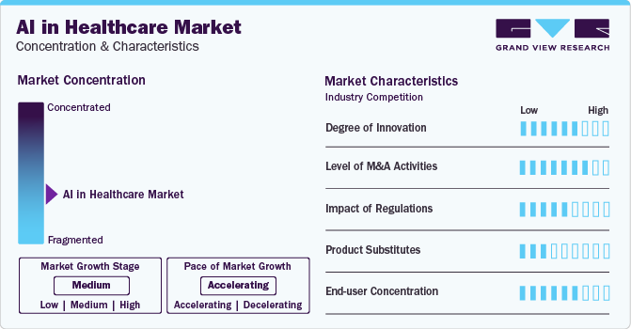

# Increased Investment & Funding

* There is a significant influx of funding from both private investors and government initiatives aimed at promoting AI adoption in healthcare. This includes investments in AI platforms, clinical research, and healthcare IT infrastructure.
* For instance, North America, particularly the U.S., holds the largest market share due to advanced healthcare IT infrastructure and supportive regulatory policies.

# Growing Market Acceptance

* Healthcare providers are increasingly recognizing the value of AI technologies in improving patient outcomes and operational efficiency. The use of AI for predictive analytics, medical imaging, and patient monitoring is becoming more prevalent.
* The integration of AI into electronic health record (EHR) and other healthcare systems is enhancing the efficiency and accuracy of clinical workflows, which is driving broader market acceptance.

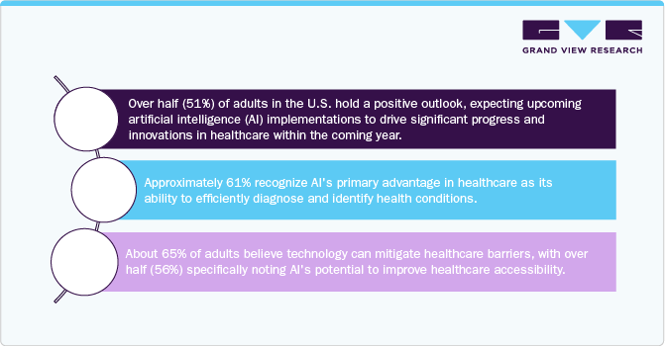

# Competitive Landscape

* The industry is highly competitive, with established players like Philips Healthcare, GE Healthcare, and Siemens Healthineers, as well as numerous startups, fighting for market share.

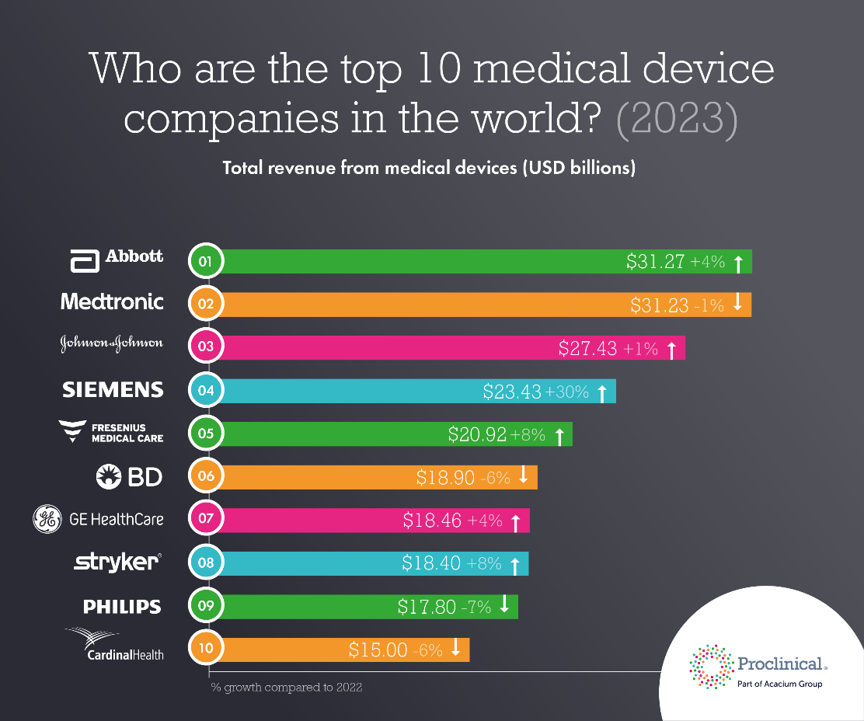

* Companies are differentiating themselves through continuous innovation, strategic partnerships, and by offering comprehensive AI solutions that address specific healthcare needs.

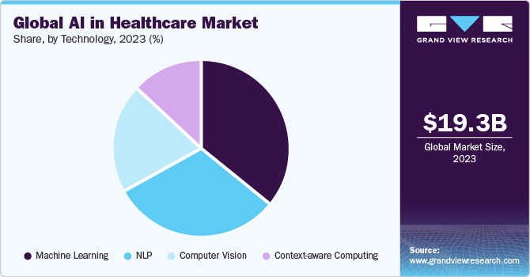

# Philips Healthcare Value Chain Analysis

The value chain is a business model used to examine all company activities, consisting of Inbound Logistics, Operations, Outbound Logistics, Marketing and Sales and Service.

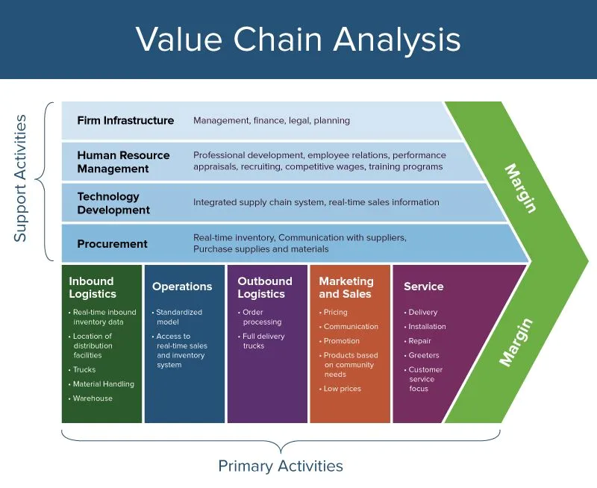

# Inbound Logistics

Inbound Logistics is about receipt, storage, and distribution of inputs. Philips sources advanced components like the AI chips, cloud computing resources, and specialized software from various suppliers to ensure the quality and efficiency of their AI healthcare solutions. For example, establishing strategic partnerships with suppliers with NVIDIA for AI chips and AWS for cloud services ensure a steady supply of critical components. Hence, efficient management of inbound logistics reduce costs and ensures the availability of high-quality inputs, directly contributing to higher margins and competitive advantage.

# Operations

Operations is about transforming inputs into the final products. This involves developing AI-driven healthcare solutions, integrating AI algorithms into medical devices, and ensuring product quality. For example, the development of AI-powered diagnostic tools, such as the IntelliSpace AI Workflow Suite, enhances diagnostic accuracy and efficiency. Therefore, streamlined operations a continuous innovation in AI technologies improve productivity and reduce operational costs, enhancing algorithms and maintaining competitive edge.

# Outbound Logistics

Outbound logistics is about distribution of the final products to customers. This ensures that their AI-driven healthcare solutions reach hospitals, clinics, and other healthcare providers efficiently. For example, utilizing efficient distribution network to deliver AI-powered imaging systems to medical facilities worldwide. Hence, effective outbound logistics ensure timely delivery and customer satisfaction, which can lead to repeat of business and increased margins.

# Marketing and Sales

Marketing and sales are about promoting and selling products to customers. This means highlighting the benefits of AI in healthcare, demonstrating improved patient outcomes and operational efficiencies. For example, marketing campaigns showcasing the capabilities of AI-driven solution sin improving diagnostic accuracy and patient care, such as promoting the AI-based solutions at healthcare conferences and through digital marketing channels.

# Services

Services is about providing after-sales support and services to customers. Philips offer comprehensive support for their AI healthcare solutions, including maintenance, training, and updates. For example, they provide 24/7 technical support and regular updates for AI systems to ensure optimal performance and customer satisfaction. Therefore, high-quality service enhances customer loyalty and retention, which can lead to long-term streams and improved margines.

# Philips Healthcare SWOT Analysis

SWOT analysis is a technique for assessing the performance, competition, risk, and potential of a business, as well as part of a business such as a product line or division, an industry, or other entity.

* SWOT analysis is a strategic planning technique that provides assessment tools.
* Identifying core strengths, weaknesses, opportunities, and threats lead to fact-based analysis, fresh perspectives and new ideas.
* Using internal and external data, a SWOT analysis can tell a company where it needs to improve internally, as well as help develop strategic plans.

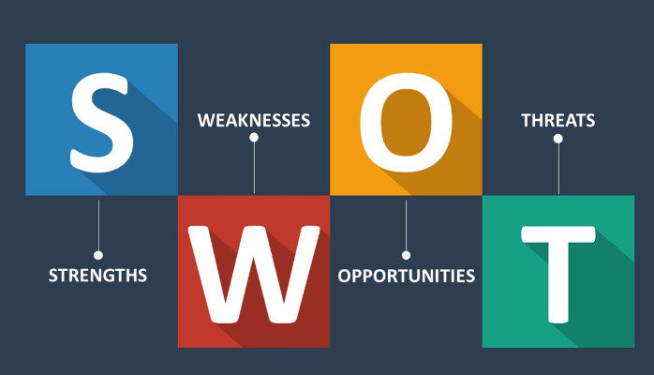

So what is the Philips Healthcare SWOT?

# Strengths

* **Brand Reputation:** Philips is a globally recognized brand which are known for their quality and reliability. They are associated with innovation, trust, and excellence, key differentiators in the highly competitive health technology market.
* **Diversified Portfolio:** Philips offers a diverse range of products and services across the health technology spectrum, including personal health, diagnosis & treatment, connected care, and health informatics. This diversification allows the company to mitigate risks associated with dependence on a single market segment.
* **Strong Research & Development (R&D):** Philips strongly focuses on R&D, which allows the company to constantly innovate and create new products that cater to changing market needs. This culture of innovation is a significant strength that helps maintain a competitive edge.
* **Commitment to Sustainability:** Philips is well-regarded for its commitment to sustainability and corporate responsibility. This commitment benefits the company’s public image and positions it well for future regulatory changes and consumer trends that favor sustainable businesses.

# Weaknesses

* **Product Recalls:** Philips has faced issues with product recalls in the past, which can harm the company’s reputation, which incurred significant costs and resulted in loss of sales. For example, in 2020, Philips recalled certain ventilators and sleep apnea machines due to the potential health risks found.
* **Dependence on Suppliers:** Philips relies on several key suppliers for components of its products. Any disruption in these supply chains could affect the company’s ability to manufacture and distribute its products, impacting sales and probability.
* **High Prices:** Concerns about Philips’ pricing policies have been raised by customers, who believe that the company’s good are more costly than those of comparable companies. Price-conscious consumers may be turned off by this premium pricing perception, which would reduce the market share that Philips may successfully target. To stay ahead of the competition and draw in new clients, where Philips competes on value rather than price, must ensure that the premium pricing they are charging are backed by exceptional innovation, quality, and service.
* **Better Demand Forecasting:** Precise demand projection is essential for effective production and inventory control. Due to their miscalculation of market demand, Philips has come under fire for either over -or under producing products. The financial losses resulting from unsold inventory or lost sales opportunities due to product shortages might be caused by these forecasting errors. To better match output to market demand, the company must improve its demand forecasting skills.

**[](https://www.youtube.com/embed/OiatEjFqf2w?feature=oembed)**

# Opportunities

* **Rising Demand for Healthcare Technologies:** With an aging global population and increasing prevalence of chronic diseases, the demand for healthcare technologies is on the rise. Philips can leverage this opportunity by developing innovative and effective healthcare solutions.
* **Telehealth & Remote Patient Monitoring:** The COVID-19 pandemic has accelerated the adoption of telehealth and remote patient monitoring technologies. With its strong presence in the connected care and health informatics segment, Philips is well positioned to capitalize on this trend.
* **Growth in Emerging Markets:** Emerging markets like China, India, and Brazil offer significant growth opportunities due to increasing healthcare expenditures and improving healthcare infrastructure.Philips’ established presence in these markets can be leveraged for further expansion.
* **Artificial Intelligence (AI) in Healthcare:** AI has enormous potential in the healthcare industry, from improving diagnostic accuracy to personalizing patient care. The company could become a leading player, given Philips’ investments in AI and data analytics.

**[](https://www.youtube.com/embed/KeU7UDsV8-c?feature=oembed)**

# Threats

* **Intense Competition:** The health technology industry, in which Philips is active, is filled with intense competition from international and local players. These rivals never stop innovating and using cutting-edge technologies to break the industry. If competitors introduce revolutionary new technology, it may significantly reduce the market for Philips’ products. For example, Philips’ conventional health monitoring gadgets may be directly threatened by competitors’ emergence of wearable health technology.
* **Regulatory Changes:** Philips, who is a major player in the healthcare and technology industries, struggles with strict rules. A sudden change in laws governing privacy or medical device standards could cause operational difficulties for the business and reduce its profitability. One recent example that forced many IT companies to revise their data privacy policies was the implementation of GDPR in Europe.
* **Cybersecurity & Data Privacy:** Given the sensitive nature of health-care data that Philips handles, the company could be a target for cyberattacks. Any breach of data could result in significant reputational damage such as trust being lost and financial losses.
* **Global Economic Conditions:** Macroeconomic changes can affect Philips and its customers’ purchasing power in today’s connected world. Consumer demand may be significantly restricted by an economic slowdown, unpredictable geopolitical conditions, or changes in exchange rates, particularly in merging nations where prices are crucial. For instance, the global decline in consumer spending that followed the 2008 financial crisis highlights the possible problems associated with this aspect.

# Philips Healthcare BCG Model

The BCG Matrix, also known as Boston Consulting Group Matrix, categorizes a company’s products or business units based on market growth and relative market share. Given the rapid growth in the MedTech and AI in Healthcare market and Philips Healthcare’s strong presence and innovative products in this space, it likely fits into the **“Star”** category.

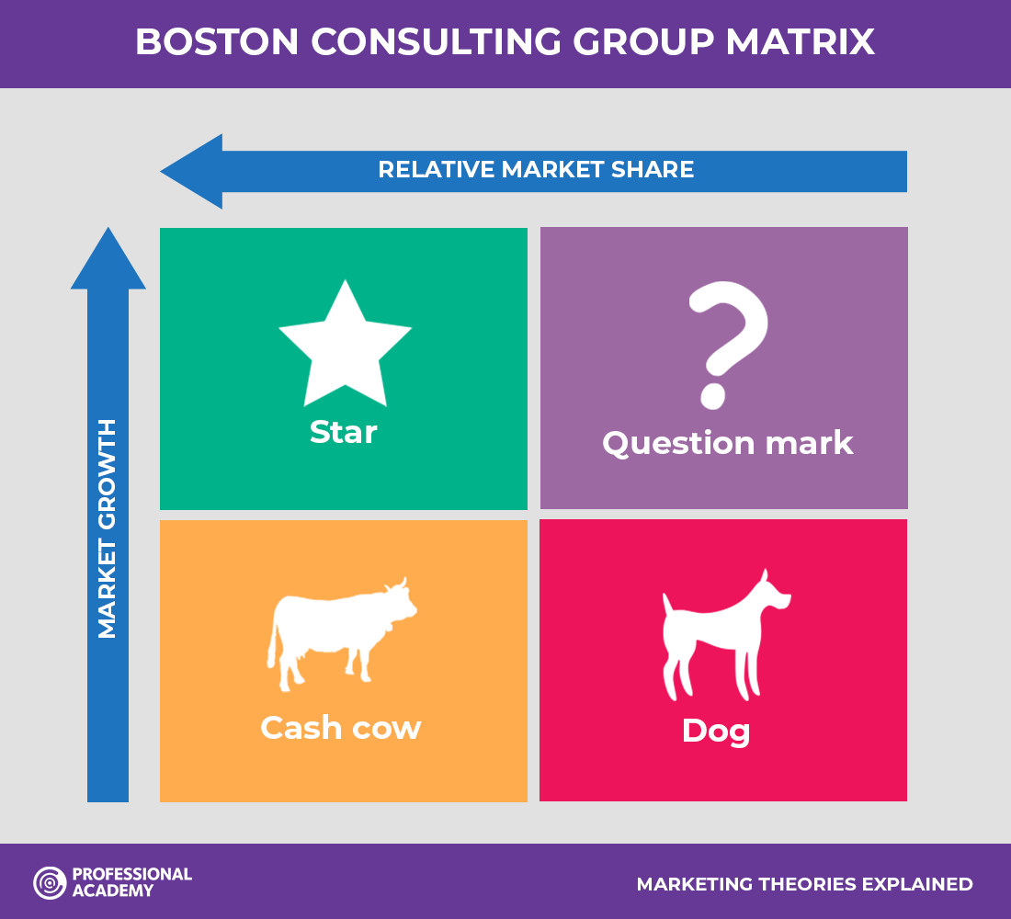

# High Market Growth

* **Market Expansion:** The global AI in healthcare market is expected to grow at a compound annual growth rate (CAGR) of approximately 38.5% from 2024 to 2030. This growth is driven by increasing demand for advanced diagnostic tools, personalized medicine, and efficient patient management systems.

# High Market Share

* **Technological Leadership:** Philips Healthcare is a leading player in the MedTech industry, especially in AI-driven healthcare solutions. Products like the IntelliSpace AI workflow Suite exemplify Philips’ capability to provide advanced diagnostic accuracy and operational efficiency.

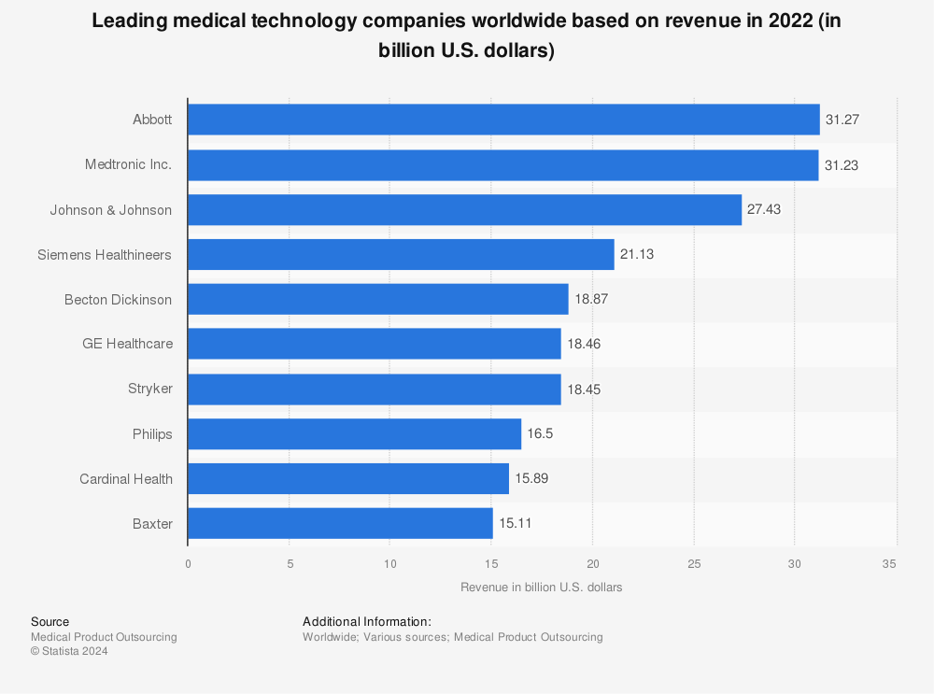

# Philips Healthcare Product Life Cycle

Based on the Product Life Cycle, Philips HealthCare’s AI solutions is likely to be in the “Growth” stage.

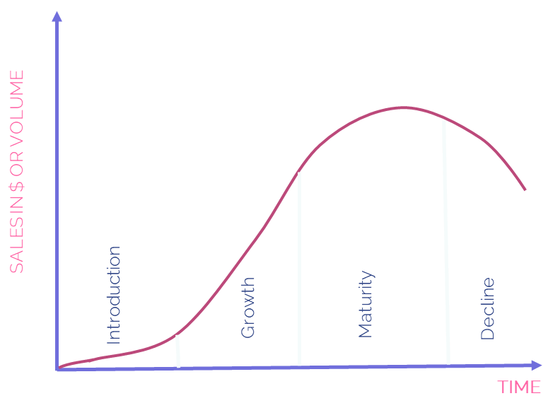

# Rapid Adoption & Integration

Philips has been actively integrating AI solutions across various healthcare applications, such as SmartExam for automating MRI exam planning and SmartSpeed for enhancing MRI imaging quality. These solutions are being adopted by a growing number of healthcare institutions, which is a hallmark of the growth phase.

# Expansion & Scaling

Philips collaboration with Amazon SageMaker to create the Ai ToolSuite Platform is designed to support scalable AI/ML development. This platform facilitates the production, monitoring, and maintenance of AI models, indicating a focus on expanding their capabilities and scaling operations to meet increasing demand.

# Market Penetration & Revenue Growth

The growth phase is characterized by increasing market penetration and revenue. Philips’ AI solutions, like the AI Manager platform and various AI-enabled imaging tools, are being integrated into more healthcare settings, which aligns with a period of revenue growth and expanding market presence.

# Recommendations

Based on the research and analysis conducted on Philips Healthcare, as mentioned earlier on it is still within the growth stage. With the MedTech industry growing exponentially, there is still a lot of room for growth and unseen potential. Therefore, I strongly believe that the products that Philips Healthcare have to offer like their diagnostic imaging, predictive analysis software, IntelliSpace Suite of products, and more…. Should have continued investment to continue making it even more reliable, accurate and robust. Ensuring that it can go above and beyond to benefit the society and improve the lives of people with its continued innovation. Here are 3 recommendations I would make to ensure that the continuous investment made is well invested to improving operations and inspire greater innovation.

# Enhance Research & Development (R&D)

* **Increase R&D Funding:** By allocating more resources to R&D to drive greater innovation in AI-centric healthcare solutions, there will be greater development for cutting-edge AI algorithms and improve existing technologies.

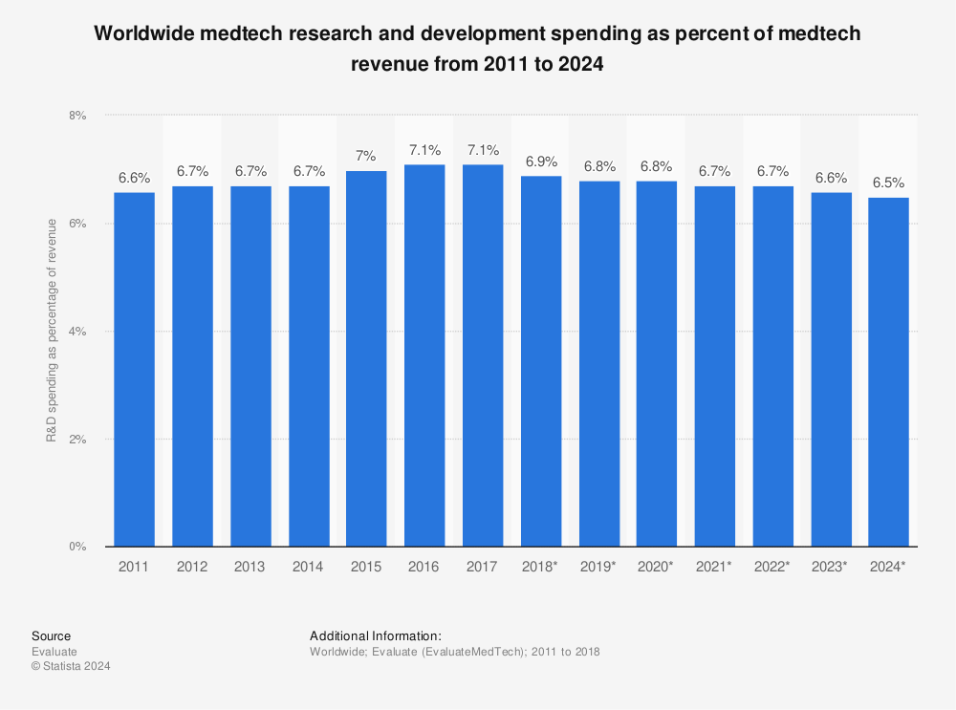

* **Collaborative Research:** Philips’ can partner with more academic institutions and research organization to stay at the forefront of AI advancements and allow them to gain access to latest research and technologies.

# Enhance Cybersecurity & Data Privacy

* **Robust Security Measures:** Invest in better advanced cybersecurity measures to maintain and protect the sensitive healthcare data that can include patients sensitive record from data breaches and cyberattack.

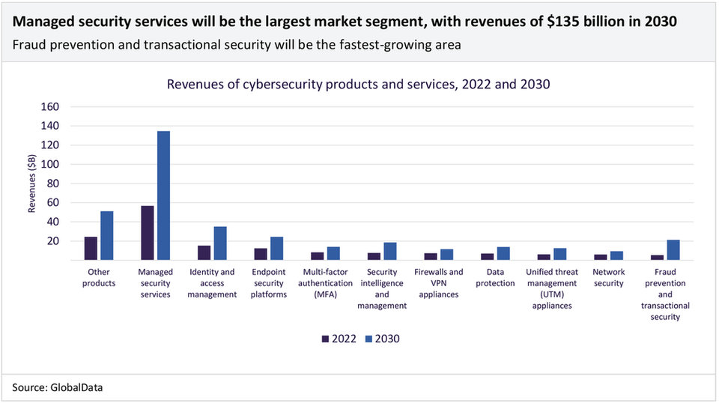

* **Compliance with Regulations:** Ensure that there is full cooperation and comply with data privacy laws and regulation such as the GDPR, where it is continuously being updated on their policies and constantly reflect the latest requirements.

# Focus on Sustainability

* **Sustainable Practices:** Implement sustainable practices in the development and deployment of AI healthcare solutions to align with Philips’ commitment to corporate responsibility and environmental sustainability.

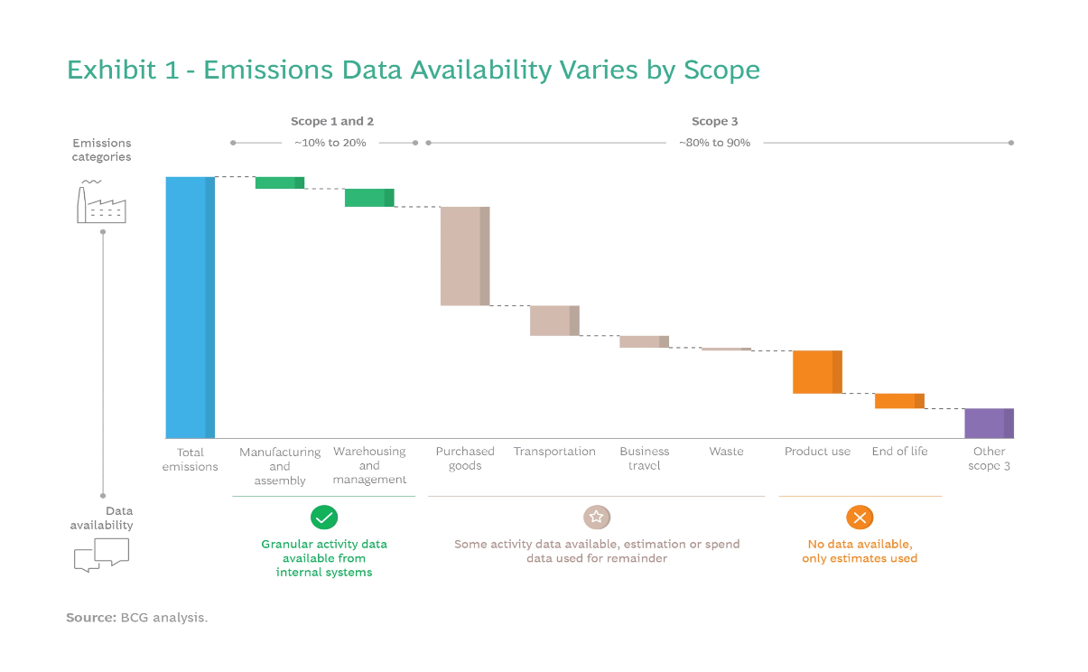

* **Green Technologies:** Invest more in the development of environmentally friendly technologies and products that meet regulatory standards and consumer preferences, so that they can receive more grants from government bodies as they favor products that produces sustainable solutions while benefitting society.

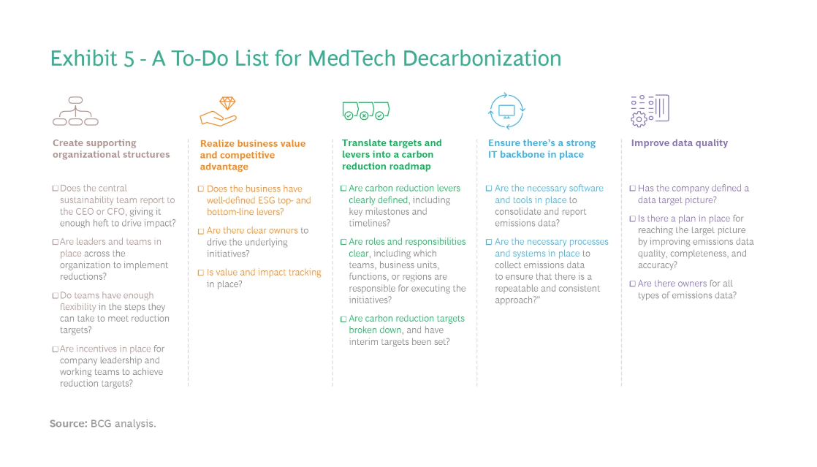

# Conclusion

Going through this assignment, I have learned quite a lot such as expanding my domain knowledge within the MedTech and AI in Healthcare industry, keeping up with past and present events within the industry and learn the various reasons why certain factors can impact a company of such a big scale like Philip’s significantly. I will be showing how AI tools like ChatGPT, Gemini and Co-pilot have aided in my research and understanding in this assignment.

# Problem Identification

The healthcare industry is facing significant challenges in meeting the increasing demands for efficient and effective patient care. Traditional methods often fall short in addressing the complexities and vast amounts of data generated within healthcare systems.

The problem identified is that AI Enhanced Healthcare Solutions are increasingly necessary to support the growing healthcare needs, particularly in improving the delivery of treatments to consumers. The existing healthcare infrastructure struggles to keep pace with the rising patient volumes, demand for personalized care, and the need for rapid and accurate diagnostics.

# AI Tools Chosen

Seeing the content needed to research on such as the

1. PEST Analysis
2. 5 force model for the intersection of the MedTech and AI in Healthcare market
3. The Industry Life cycle
4. Value Chain Analysis for Philip’s Healthcare
5. SWOT Analysis on Philip’s Healthcare
6. BCG Model
7. Product Life Cycle

I used AI tools such as ChatGPT, Gemini and Co-Pilot to conduct my research on these categories.

# Interaction with AI Tools

As I navigate my way researching the categories on the industry and Philip’s Healthcare, at time I receive different inputs from the different AI tools used. With some providing information with source links provided, some being constantly repetitive, or some based off on the knowledge it got without any source to link to the facts. There have been a constant mix of responses, to improve the output result.

Firstly, I ask the AI to provide me with the source links to determine where the information comes from. When I am skeptical of the information provided, I do fact check by searching it online to check if any articles can relate or confirm the information, for example, partnerships between NVIDIA or AWS. Nonetheless, I do read up on the articles found on various website or news outlet to expand my domain knowledge of the MedTech and AI in healthcare market to ascertain if the information is relevant or inaccurate.

Secondly, using some of the prompt engineering skillsets that I have picked up externally, I gave the AI better context, specific instructions and conditions to narrow the response so that the output when produced is more specific and accurate, one way to ensure the AI is not hallucinating or providing irrelevant/inaccurate information is by iterating the main context and constant memory update, when providing the information, I prompt to provide into the PEEL format (Point, Explanation, Example, Link) to ensure that it is able to clearly explain the information provided, which helps to increase result accuracy and better output performance across the AI tools I chose.

# Reflection

All in all, with the techniques used and the constant reminder to myself that some AI tools have a knowledge cut off date. I was able to leverage on the 3 AI Tools chosen (ChatGPT, Gemini, Co-Pilot) and utilize them to providing as much accurate information as possible as using intervening using human judgment to determine if it make senses. Below are the references for the AI tools used.

ChatGPT: <https://chatgpt.com/?model=text-davinci-002-render-sha>

Gemini: <https://gemini.google.com/app>

Co-Pilot: <https://copilot.microsoft.com/>

# Citations & References

Here are the citations & references to websites such as articles or information used to do my research and findings.

*Our history | Philips*. (n.d.). Philips. https://www.philips.com/a-w/about/our-history.html

Mahru, M. (2023, February 3). *Koninklijke Philips SWOT and PESTLE Analysis*. SWOT & PESTLE.com. https://www.swotandpestle.com/koninklijke-philips/

Team, M. S. (2019, December 25). *Philips PESTLE Analysis*. MBA Skool. https://www.mbaskool.com/pestle-analysis/companies/18000-philips.html

Team, M. S. (2022, February 26). *Philips Porter Five Forces Analysis*. MBA Skool. https://www.mbaskool.com/five-forces-analysis/companies/18334-philips.html

Adamkasi. (2021, June 9). *Porter’s Five Forces Analysis - Philips - Porter Analysis*. Porter Analysis. https://www.porteranalysis.com/porters-five-forces-analysis-philips/

*Topic: Philips*. (2024, May 8). Statista. https://www.statista.com/topics/2714/philips/#topicOverview

*Philips presents its plan to create value with sustainable impact*. (2023, March 6). Philips. https://www.philips.com/a-w/about/news/archive/standard/news/press/2023/20230130-philips-presents-its-plan-to-create-value-with-sustainable-impact.html

*Our strategic focus | Philips*. (n.d.). Philips. https://www.philips.com/a-w/about/our-strategy.html

*Logistical and Value Chain Strategies at Philips*. (2023, November 6). https://sg.ukessays.com/essays/management/logistical-and-value-chain-strategies-at-philips-management-essay.php

Kent, C. (2022, November 11). Philips bets big on connected care with recent acquisitions. *Medical Device Network*. https://www.medicaldevice-network.com/features/philips-connected-care/#:~:text=Health%20tech%20giant%20Royal%20Philips,cash%20consideration%20of%20%24635m

*Bloomberg - Are you a robot?* (2023, October 23). https://www.bloomberg.com/news/articles/2023-10-23/philips-lifts-outlook-on-continued-supply-chain-improvement

*Philips and AWS collaborate to scale digital pathology in the cloud, enhancing diagnostic capabilities and improving productivity*. (2024, March 11). Philips. https://www.philips.com/a-w/about/news/archive/standard/news/press/2024/philips-and-aws-collaborate-to-scale-digital-pathology-in-the-cloud-enhancing-diagnostic-capabilities-and-improving-productivity.html#:~:text=Philips'%20collaboration%20with%20AWS%20has,cases%2C%20including%20in%20cancer%20care.

*Philips extends AI portfolio with launch of IntelliSpace AI Workflow Suite to seamlessly integrate applications across imaging workflows*. (2023, December 21). Philips. https://www.philips.com/a-w/about/news/archive/standard/news/press/2019/20191201-philips-extends-ai-portfolio-with-launch-of-intellispace-ai-workflow-suite-to-seamlessly-integrate-applications-across-imaging-workflows.html

*Philips Patient Engagement and Healthcare Analytics | Philips*. (n.d.). Philips. https://www.philips.com.sg/healthcare/e/enterprise-telehealth/patient-engagement-and-healthcare-analytics

*AI in cardiovascular ultrasound to diagnose more patients*. (2024, June 4). Philips. https://www.philips.com/a-w/about/news/archive/standard/news/press/2024/ai-in-cardiovascular-ultrasound-to-diagnose-more-patients.html#:~:text=Through%20breakthrough%20innovation%20and%20collaborations,cardiology%20care%20to%20an%20increasing

*Advancing Precision Diagnosis with AI at Philips: Approaches, Use Case, and Challenges | NVIDIA On-Demand*. (n.d.). NVIDIA. https://www.nvidia.com/en-us/on-demand/session/gtcfall21-a31313/

*AI In Healthcare Market Size, Share & Trends Analysis Report By Component (Hardware, Services), By Application, By End-use, By Technology, By Region, And Segment Forecasts, 2024 - 2030*. (n.d.). https://www.grandviewresearch.com/industry-analysis/artificial-intelligence-ai-healthcare-market

Jayaraman, S. (2023, December 4). *4 Experts Share How AI Is Transforming Healthcare in 2024*. https://learn.g2.com/ai-in-healthcare-trends

*2024 Life Sciences and Health Care Industry Outlooks and Insights*. (n.d.). Deloitte United States. https://www2.deloitte.com/us/en/pages/life-sciences-and-health-care/articles/healthcare-industry-insights-outlooks.html

Southwick, R. (2023, December 20). Health technology in 2024: Projections for AI, digital health, and more. *OncLive*. https://www.chiefhealthcareexecutive.com/view/health-technology-in-2024-projections-for-ai-digital-health-and-more

Momin, A. (2024, April 9). *PHILIPS SWOT Analysis: Commitment to Innovation*. PESTLE Analysis. https://pestleanalysis.com/philips-swot-analysis/

Team, M. S. (2023, June 1). *Philips SWOT Analysis*. MBA Skool. https://www.mbaskool.com/brandguide/conglomerates/7939-philips.html

Admin. (2023, June 16). *Philips SWOT Analysis - The Strategy Story*. The Strategy Story - Simplifying Business Strategies. https://thestrategystory.com/blog/philips-swot-analysis/

Ltd, R. a. M. (n.d.). *Global AI in Healthcare Market Size, Share & Trends Analysis Report by Component (Software Solutions, Hardware, Services), Application (Virtual Assistants, Connected Machines), Region, and Segment Forecasts, 2024-2030*. Research and Markets ltd 2024. https://www.researchandmarkets.com/reports/5351653/global-ai-in-healthcare-market-size-share-and

*AI-enabled solutions | Philips*. (n.d.). Philips. https://www.philips.com/a-w/about/artificial-intelligence/ai-enabled-solutions.html#triggername=less3_isc3

Bhasin, H. (2024, May 28). *SWOT Analysis of Philips (Updated 2024)*. Marketing91. https://www.marketing91.com/swot-analysis-philips/

*BCG Matrix and VRIO Framework for Philips Healthcare Latin America*. (n.d.). Case48. https://www.case48.com/bcg-case/12293-Philips-Healthcare-Latin-America

*Philips accelerates development of AI-enabled healthcare solutions with an MLOps platform built on Amazon SageMaker | Amazon Web Services*. (2023, November 16). Amazon Web Services. https://aws.amazon.com/blogs/machine-learning/philips-accelerates-development-of-ai-enabled-healthcare-solutions-with-an-mlops-platform-built-on-amazon-sagemaker/

*Philips presents its plan to create value with sustainable impact*. (2023b, March 6). Philips. https://www.philips.com/a-w/about/news/archive/standard/news/press/2023/20230130-philips-presents-its-plan-to-create-value-with-sustainable-impact.html

*Who are the top 10 medical device companies in the world in 2023? | Proclinical Recruitment Blogs*. (n.d.). Proclinical. https://www.proclinical.com/blogs/2023-10/top-10-medical-device-companies-in-the-world-in-2023

Wurzer, C., Hansen, F., Surtevall, E., Tziambazis, E., O’Brien, C., & Eichelberger, M. (2024, May 14). *MedTech’s Green Moment Is Here*. BCG Global. https://www.bcg.com/publications/2023/how-medtech-ceos-can-meet-esg-goals

*The state of cybersecurity in 2023 - Medical Technology | Issue 63 | June 2023*. (2024, May 22). https://medical-technology.nridigital.com/medical_technology_jun23/cybersecurity-trends-market-forecast-2023

*Marketing Theories – Boston Consulting Group Matrix*. (n.d.). https://www.professionalacademy.com/blogs/marketing-theories-boston-consulting-group-matrix/

Muntasir. (2024, March 2). *Industry Life Cycle*. iEduNote. https://www.iedunote.com/industry-life-cycle

Kim, J. (2024, February 20). *Porter’s 5 Forces Model*. Wall Street Prep. https://www.wallstreetprep.com/knowledge/porters-five-forces-model/

*The Green Finance for Small and Medium-sized Enterprises (GFS) Initiative - Tropenbos International*. (n.d.). Tropenbos International. https://www.tropenbos.org/projects/the+green+finance+for+small+and+medium-sized+enterprises+(gfs)+initiative

*What is PEST Analysis?* (n.d.). https://www.visual-paradigm.com/guide/strategic-analysis/what-is-pest-analysis/

*Healthcare leaders discuss 2022 tech, investment and digitalization outlook*. (2022, February 8). World Economic Forum. https://www.weforum.org/agenda/2022/01/biggest-healthcare-shifts-experts-expect-to-see-in-2022/

*With life expectancy increasing, here’s how 4 countries are addressing their ageing populations*. (2023, September 22). World Economic Forum. https://www.weforum.org/agenda/2023/09/life-expectancy-countries-ageing-populations/

*IntelliSpace AI Workflow Suite | AI in Radiology | Philips*. (n.d.). Philips. https://www.philips.com.ph/healthcare/resources/landing/intellispace-ai-workflow-suite